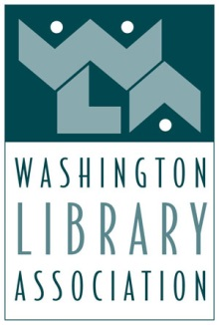

Board of Directors Meeting
Early Bird Room, Historic Davenport Hotel, Spokane, WA
April 27, 2016
4:00pm – 6:00pm

Mission Statement
The Washington Library Association provides essential resources, support and advocacy
for libraries and the people who make them great.

Core Values
Public Good, Community, Integrity, Professionalism, Responsiveness,
Inclusivity, Education, Intellectual Freedom, Leadership

AGENDA

- WELCOME & OVERVIEW

- Welcome – Darcy Brixey
- Call to Order

- President’s Report – Darcy Brixey
- Introduction of new Board Members
- New Committee Chairs – Brianna Hoffman

- Executive Director Update – Louise S. Miller, MA, CAE
(See Dashboard Report)

- STRATEGIC REVIEW and DISCUSSIONS

- Membership – Josephine Camarillo
- Update

- Marketing & Communications – Richard Counsil
- Update

- Scholarship Committee – Leah Griffin (on behalf of Anne Bingham)

- Legislative Committee Reports – Nancy Ledeboer
- National Library Legislative Day – Christine Peck
- Legislative Planning Committee End-of-Session Report – John Sheller

- Professional Development
- WALE Conference – Kate Laughlin and Brian Hulsey
- WLMA Unconference – Kate Laughlin and Craig Seasholes

III. FINANCE & OPERATIONS

- Treasurer’s Report – Irene Wickstrom
- March 2016 Financials ACTION (to accept)
- Financial Report on developments for 2017 DISCUSSION

- Approval of Minutes, December 16, 2015 Board Meeting – Irene Wickstrom ACTION (to approve)

IV. NEW BUSINESS & ADJOURNMENT

- New Business
1. RFP for association management – May 1 DISCUSSION
2. PNLA Leads – Heidi Chittim DISCUSSION
3. Social Media Guidelines Policy Rewrite – call for volunteers DISCUSSION
4. Restructuring and Rebranding DISCUSSION
5. Membership levels - $100 for non-reported salary ACTION

- Upcoming Meetings: Board Retreat, Thursday, July 7th, 9 – 4, Bellevue Library

